Dynamic Hyperparameter Optimization During Training via PBT and Hypergradient Descent

Etaash Patel · Jordan Argel · Mark Pustilnik · Satyam Sharma

Introduction

• Can cheap, within-run hyperparameter updates match a tuned static grid under tight compute?
• Small ViT on CIFAR-10, tuning learning rate, weight decay, batch size, and DropPath
• Compared: static grid, 3-stage grid, Population-Based Training (PBT), and Hypergradient Descent (HGD).
• Main finding: base online methods underperform; a richer PBT ablation (WD + batch size) recovers baseline accuracy with fewer steps

Related Work

Static HPO (grid/random/Bayesian, Hyperband), population-based methods (PBT, evolutionary) and online gradient-based hyperparameter methods (hypergrad/HGD).

Our work lies at the intersection in a small-compute, ViT-on-CIFAR-10 regime.

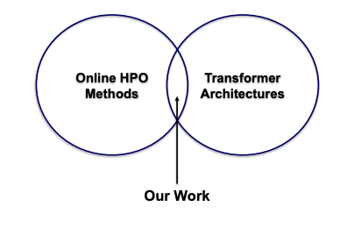

Methods

• Backbone: downsized ViT-Small (12 layers, 3 heads, dim=192, patch size 8×8)
• Dataset: CIFAR-10 with standard crop/flip; optimizer: AdamW
• Hyperparameters: learning rate, weight decay, batch size, DropPath
• Dynamic strategies:
– PBT: perturb-and-resample population
– HGD: perturb-and-probe updates for LR and WD
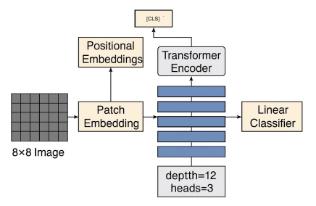
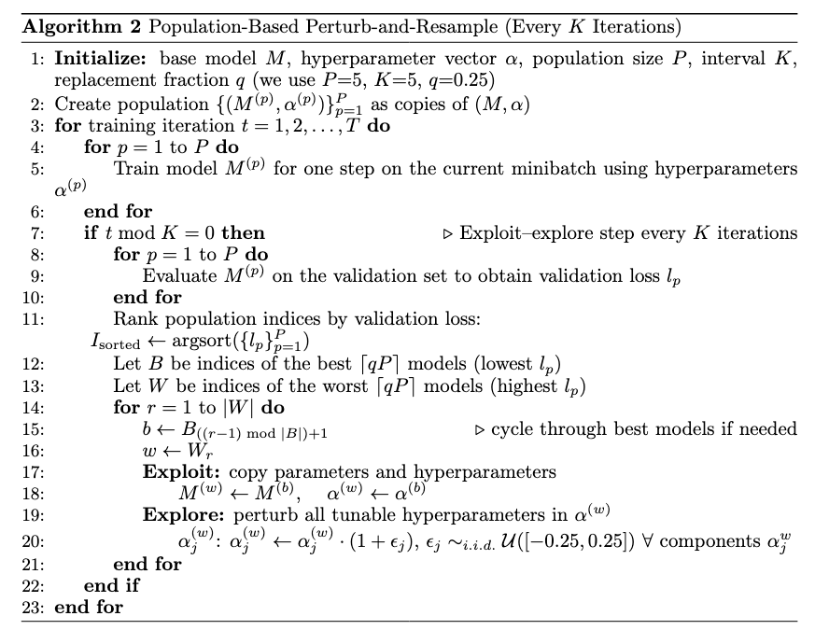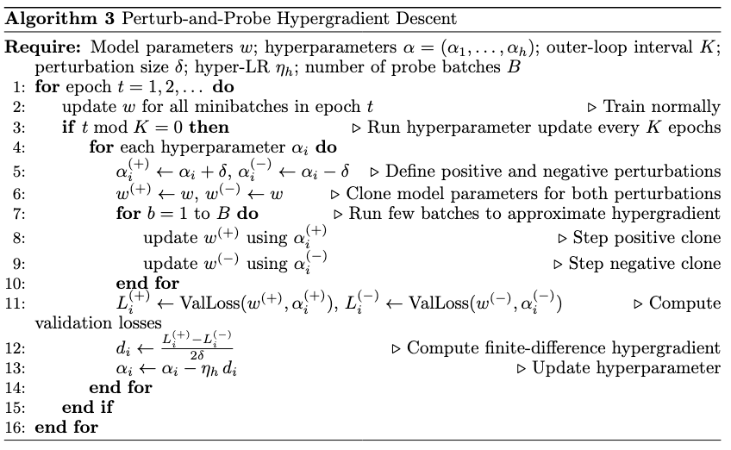

Results
• Static grid best run: ≈84–85% validation accuracy
• 3-stage grid: ≈80%; PBT (base): ≈79–80%; HGD: ≈71%
• PBT WD+BS ablation: recovers ≈84–85% accuracy with fewer total steps
• Takeaway: online HPO is not automatically better—what you adapt and how wide the search space is matters more than being online
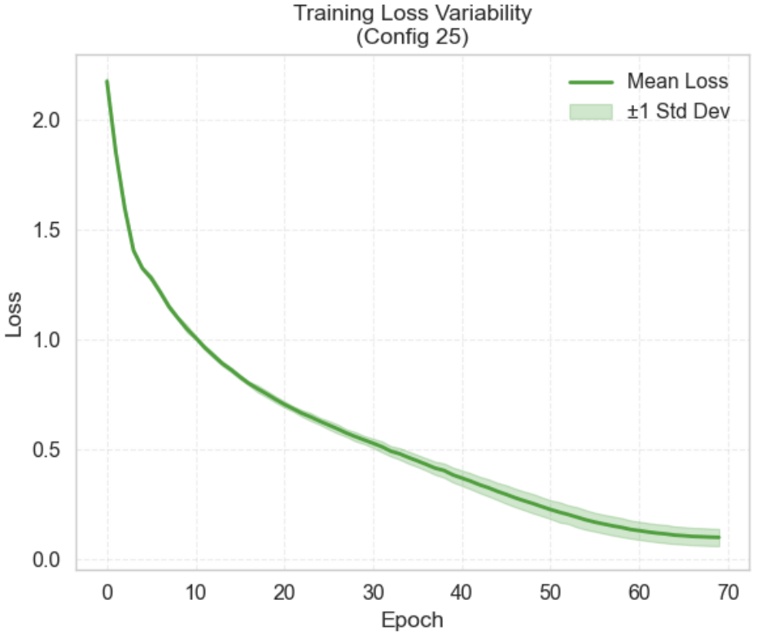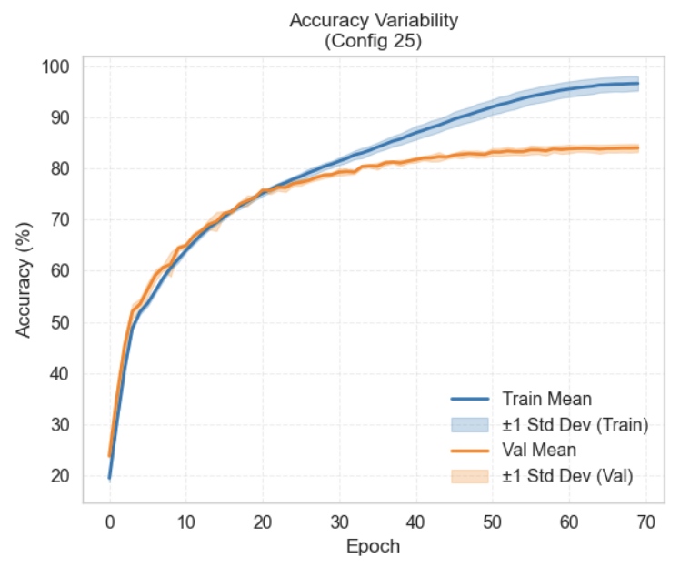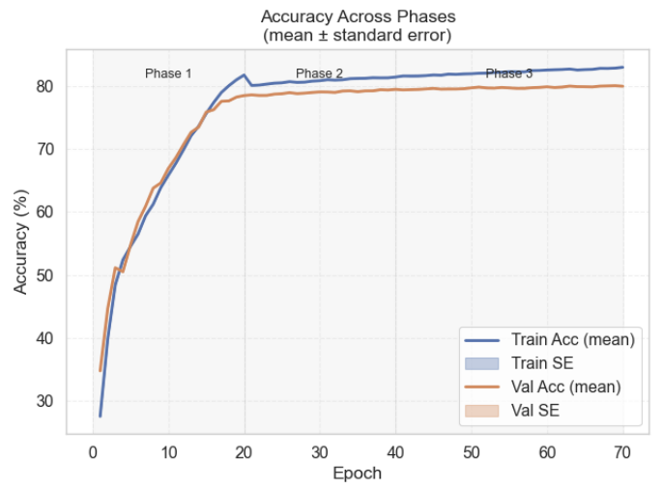
Left and middle illustrate training dynamics for the best configuration found by the static grid search. Solid lines denote the mean over 5 seeds; shaded regions show ±1 standard deviation. Left: training loss. Middle: training and validation accuracy.
Right: shows training progression of the best three-stage grid configuration for seed 38042.
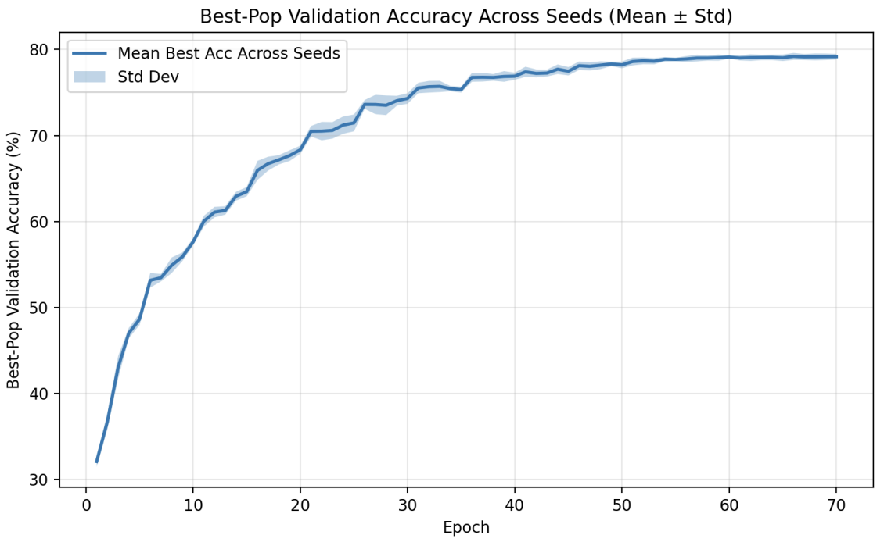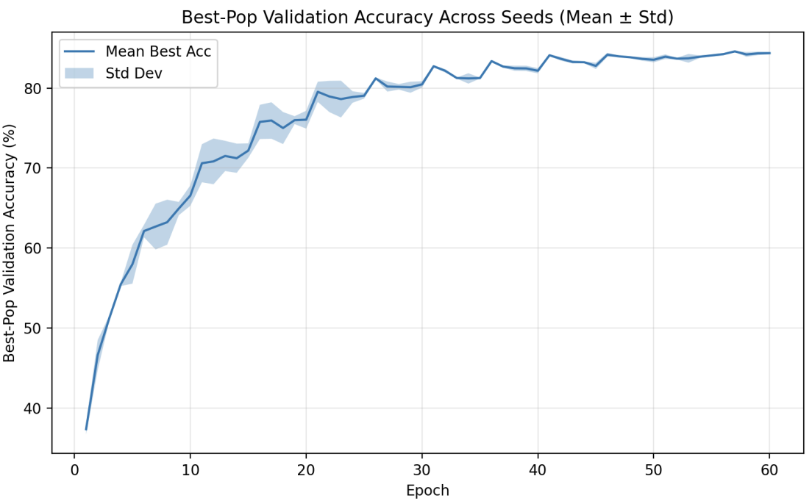
PBT aggregate best-population validation accuracy across seeds (mean ± std)
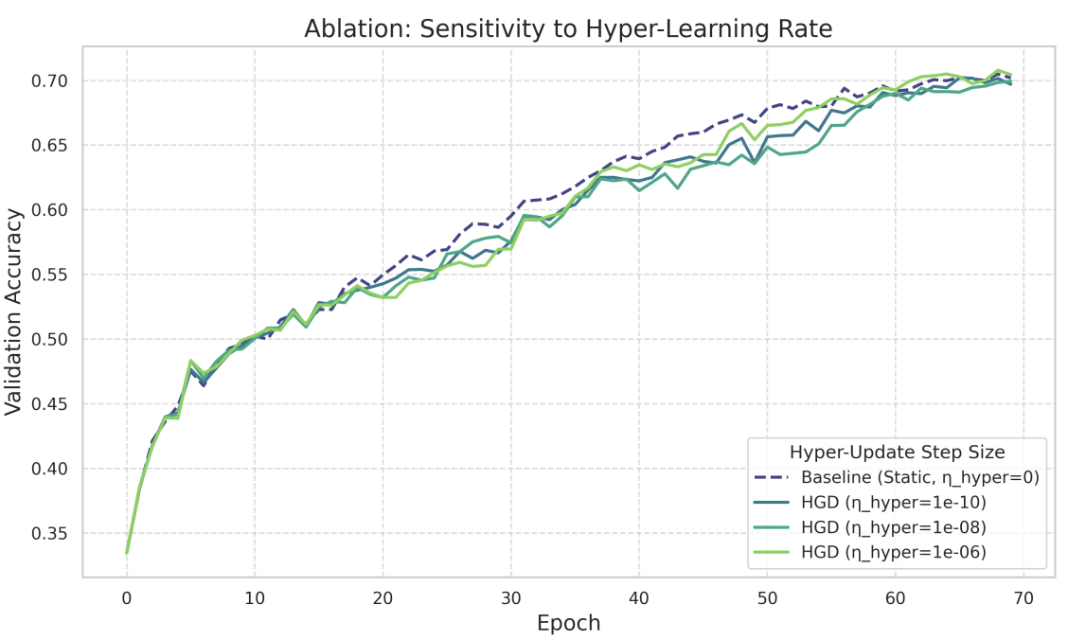
Sensitivity of validation accuracy to the hyper-learning rate for HGD

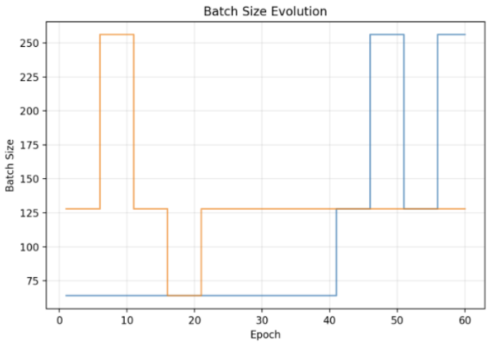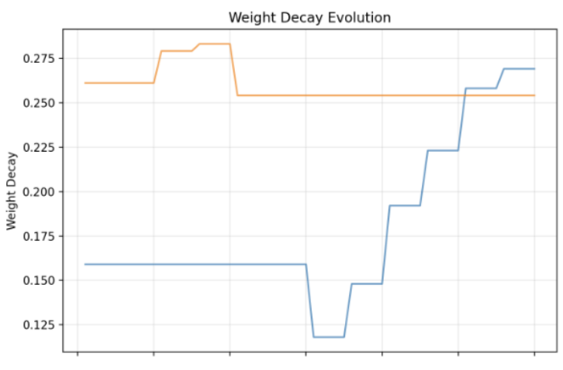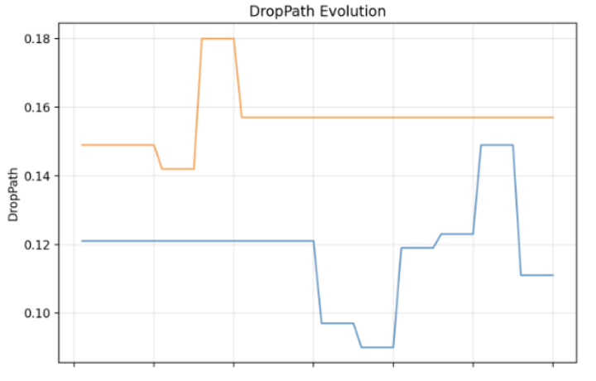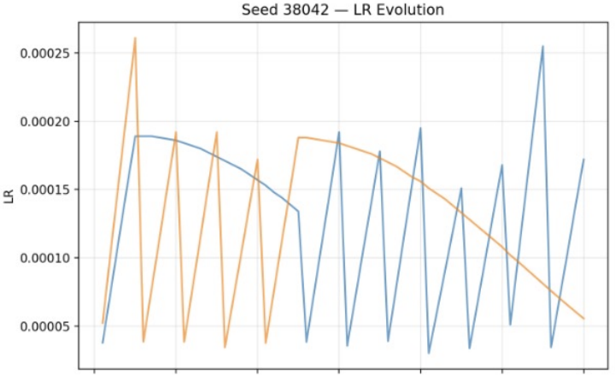
Per-seed PBT summary for seed 38042 in the weight-decay and batch-size ablation
Conclusions & Future Work:
• Simple online methods may not outperform a tuned static baseline under tight compute
• PBT is most useful when it can explore a richer space (e.g., WD + batch size)
• Future: better hypergradient estimators, larger models, and longer training horizons

References

Baydin et al., "Online learning rate adaptation with hypergradient descent," ICLR, 2017.
Donini et al., "Marthe: A meta-learning approach to hyperparameter optimization," IJCAI, 2020.
Dosovitskiy et al., "An image is worth 16x16 words: Transformers for image recognition at scale," arXiv, 2020.
Everett et al., "Scaling exponents across parameterizations and optimizers," arXiv, 2024.
Franceschi et al., "Hyperparameter optimization in machine learning," arXiv, 2024.
Jaderberg et al., "Population based training of neural networks," ICML, 2017.
Kosson et al., "Weight decay may matter more than µp for learning rate transfer in practice," arXiv, 2025.
Krizhevsky et al., "Learning multiple layers of features from tiny images," 2009.
Lau et al., "Principled adaptive batch size schedules for language model training," arXiv, 2024.
Li et al., "Predictable scale: Part I, step law," arXiv, 2025.
Li et al., "Hyperband: A novel bandit-based approach to hyperparameter optimization," JMLR, 2018.
Li et al., "Sequential policy gradient for adaptive hyperparameter optimization," arXiv, 2025.

Liu et al., "Swin transformer: Hierarchical vision transformer using shifted windows," ICCV, 2021.
Marek et al., "Small batch size training for language models," arXiv, 2025.
Morerio et al., "Curriculum dropout," CVPR, 2017.
Parker-Holder et al., "Population based bandits," NeurIPS, 2020.
Smith & Topin, "Super-convergence: Very fast training of neural networks using large learning rates," SPIE, 2017.
Touvron et al., "Training data-efficient image transformers & distillation through attention," ICML, 2021.
Urteaga et al., "Multi-armed bandits for resource efficient, online optimization of language model pre-training," ACL Findings, 2023.
Wen et al., "Fantastic pretraining optimizers and where to find them," arXiv, 2025.
Yan & Shao, "Enhancing transformer training efficiency with dynamic dropout," arXiv, 2024.
Yang et al., "A spectral condition for feature learning," arXiv, 2023.

